- Design a Bezier curve or order 4 with n=5.Read 5 points as input.
https://processing.org/reference/bezier_.html
https://processing.org/examples/bezier.html
https://bezier.readthedocs.io/en/stable/python/reference/bezier.curve.html
https://www.geeksforgeeks.org/wand-bezier-function-in-python/#:~:text=The%20bezier()%20is%20another,used%20to%20control%20the%20curve.

Code
var x1,y1,x2,y2,x3,y3,x4,y4,x5,y5,dx,dy;
function setup() {
createCanvas(800,800);
background(255);
x1=100;
y1=100;
x2=400;
y2=200;
x3=300;
y3=400;
x4=200;
y4=400;
x5=500;
y5=700;
dx=600;
dy=400;
}
function draw() {
point(x1,y1);
point(x2,y2);
point(x3,y3);
point(x4,y4);
point(x5,y5);
for(var k=0;k<=1;k+=0.00005) {
dx=(Math.pow((1-k),4))*x1+4*(Math.pow((1-k),3))*k*x2+6*(Math.pow((1-k),2))*(Math.pow(k,2))*x3+4*(1-k)*(Math.pow(k,3))*x4+(Math.pow(k,5))*x5;
dy=(Math.pow((1-k),4))*y1+4*(Math.pow((1-k),3))*k*y2+6*(Math.pow((1-k),2))*(Math.pow(k,2))*y3+4*(1-k)*(Math.pow(k,3))*y4+(Math.pow(k,5))*y5;
point(dx,dy);
}
}
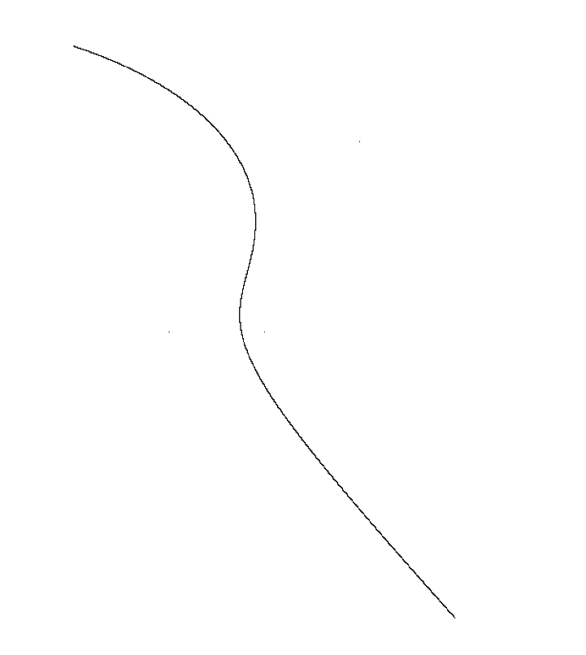

- Write a program to implement marching square algorithm to identify contours.
https://morioh.com/p/35a46fa2554c
http://tonysyu.github.io/scikit-image/auto examples/plot_contours.html
var d,cols,rows,i,j,state;
var p,q,r,s;
var m=[];
function setup() {
createCanvas(500, 500);
d=15;
cols=width/d;
rows=height/d;
for(i=0;i<cols;i++)
{
for(j=0;j<rows;j++)
{
m[i][j]=floor(random(1));
}
}
}
function draw() {
background(255,69,0);
for(i=0;i<cols;i++)
{
for(j=0;j<rows;j++)
{
strokeWeight(2);
x=i*d;
y=j*d;
point(x,y);
p=createVector(x,y+d*0.6);
q=createVector(x+d*0.6, y+d);
r=createVector(x+d,y+d*0.6);
s=createVector(x+d*0.6,y);
state=(8*m[i][j])+(4*m[i][j+1])+(2*m[i+1][j+1])+(m[i+1][j]);
strokeWeight(2);
switch(state)
{
case 1:
line(r.x,r.y,s.x,s.y);
break;
case 2:
line(r.x,r.y,q.x,q.y);
break;
case 3:
line(q.x,q.y,s.x,s.y);
break;
case 4:
line(q.x,q.y,p.x,p.y);
break;
case 5:
line(q.x,q.y,r.x,r.y);
line(p.x,p.y,s.x,s.y);
break;
case 6:
line(p.x,p.y,r.x,r.y);
break;
case 7:
line(p.x,p.y,s.x,s.y);
break;
case 8:
line(p.x,p.y,s.x,s.y);
break;
case 9:
line(p.x,p.y,r.x,r.y);
break;
case 10:
line(q.x,q.y,p.x,p.y);
line(r.x,r.y,s.x,s.y);
break;
case 11:
line(q.x,q.y,p.x,p.y);
break;
case 12:
line(q.x,q.y,s.x,s.y);
break;
case 13:
line(q.x,q.y,r.x,r.y);
break;
case 14:
line(s.x,s.y,r.x,r.y);
break;
default:
break;
}
}
}
}

